**Learning Objectives**

* To learn about table;
* To grasp table tags: table, thead, tbody, tr, th, td and caption;
* To grasp common attributes in table: colspan, rowspan and border.

**Learning Contents**

* A table is a two-dimensional structure data set composed of rows and columns. In a table, it is possible to easily and quickly find value of certain relation between different types of data.
* Here is an example of a basic table:

<table border="1">

<thead>

<tr>

<th>browser</th>

<th>render engine</th>

<th>JavaScript engine</th>

</tr>

</thead>

<tbody>

<tr>

<th>Chrome</th>

<td>Blink</td>

<td>V8</td>

</tr>

<tr>

<th>Opera</th>

<td>Blink</td>

<td>V8</td>

</tr>

</tbody>

</table>

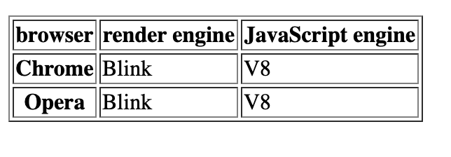

* Detailed description of table tag:
  + table - It defines a table.
  + thead - Table header;
  + tbody - Table body;
  + tr - Table row ;
  + th - Table head;
  + td - Table data
  + border - It defines whether a table has a border and its value defines width of the border.
* table tag should have a correct nesting method. table defines a table; its sub-layers nest thead and tbody; header and body nest a table row tr in them respectively; the innermost layer is table data td.
* Table rows can be merged. For example:

<table border="1">

<thead>

<tr>

<th>browser</th>

<th>render engine</th>

<th>JavaScript engine</th>

</tr>

</thead>

<tbody>

<tr>

<th>Chrome</th>

<td rowspan="2">Blink</td>

<td rowspan="2">V8</td>

</tr>

<tr>

<th>Opera</th>

</tr>

</tbody>

</table>

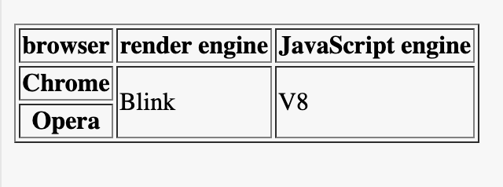

* rowspan indicates how many rows a column spans over to merge. Similarly, we can use colspan to indicate how many columns a row spans over to merge. For example:

<table border="1">

<thead>

<tr>

<th>Browser</th>

<th>Chrome</th>

<th>Opera</th>

<th>Firefox</th>

<th>Edge</th>

</tr>

</thead>

<tbody>

<tr>

<th>render engine</th>

<td colspan="2">Blink</td>

<td>Gecko</td>

<td>Edge</td>

</tr>

</tbody>

</table>

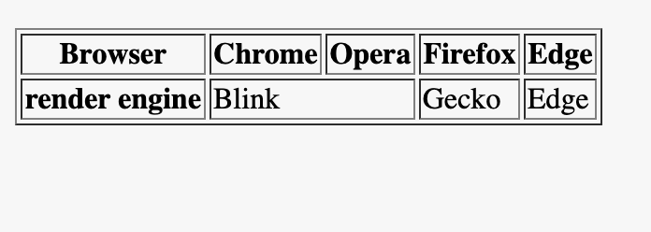

* We can also indicate a table header with caption tag. For example:

<table border="1">

*<!-- caption must be the first element of a table -->*

<caption>browsers and their engines</caption>

<thead>

<tr>

<th>Browser</th>

<th>Chrome</th>

<th>Opera</th>

<th>Firefox</th>

<th>Edge</th>

</tr>

</thead>

<tbody>

<tr>

<th>render engine</th>

<td colspan="2">Blink</td>

<td>Gecko</td>

<td>Edge</td>

</tr>

</tbody>

</table>

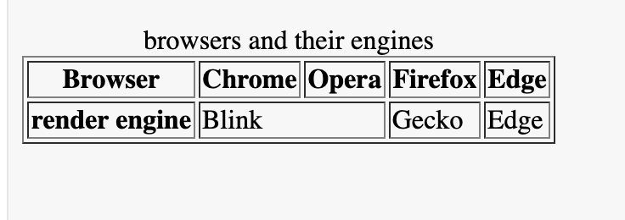

* In table tag, we can also group columns with colgroup. For example:

<table border="1">

<colgroup>

<col class="browser">

<col class="engine" span="2">

</colgroup>

<thead>

<tr>

<th>browser</th>

<th>render engine</th>

<th>JavaScript engine</th>

</tr>

</thead>

<tbody>

<tr>

<th>Chrome</th>

<td>Blink</td>

<td>V8</td>

</tr>

<tr>

<th>Opera</th>

<td>Blink</td>

<td>V8</td>

</tr>

</tbody>

</table>

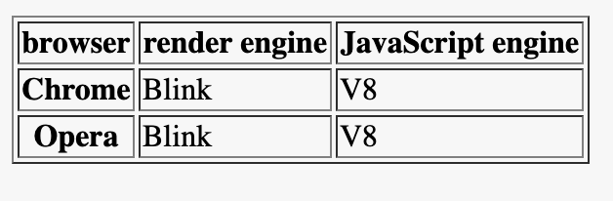

**Recommended Resources**

* Introduction to HTML Form (<https://developer.mozilla.org/en-US/docs/Learn/HTML/Tables/Basics>)
* HTML Tables (<https://www.w3schools.com/html/html_tables.asp>)